ElderOS Vision
AI-Powered Room Safety for Long-Term Care

The Problem LTC Executives Face
- Falls remain one of the top liability drivers
- Night shifts operate with limited visibility
- Staff shortages increase risk exposure
- Incidents are often discovered after the fact
- Privacy concerns limit traditional monitoring
You are accountable for safety, compliance, and cost control — without increasing headcount.

The Shift: From Reactive to Proactive Safety
Traditional model:
- Call bell pressed
- Fall discovered
- Report written
- Investigation begins
ElderOS model:
- AI detects risk in real-time
- Alert sent immediately
- Event logged automatically
- Shift summary generated

What ElderOS Vision Is
A stand-alone AI room safety system that installs in days and operates without EHR integration.
- On-prem AI processing
- One camera per room
- Real-time fall & bed exit detection
- Night wandering alerts
- Auto shift summaries
- Privacy-first design
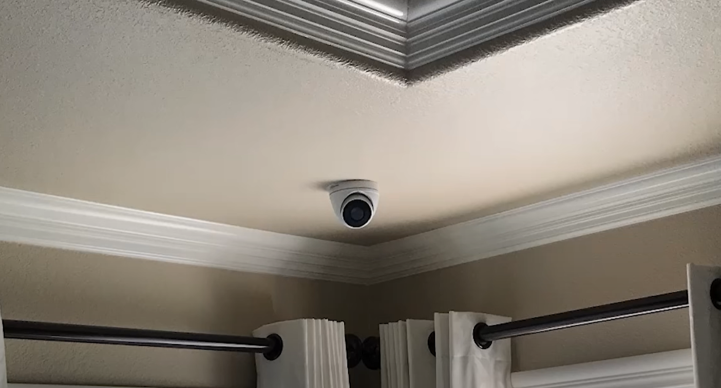

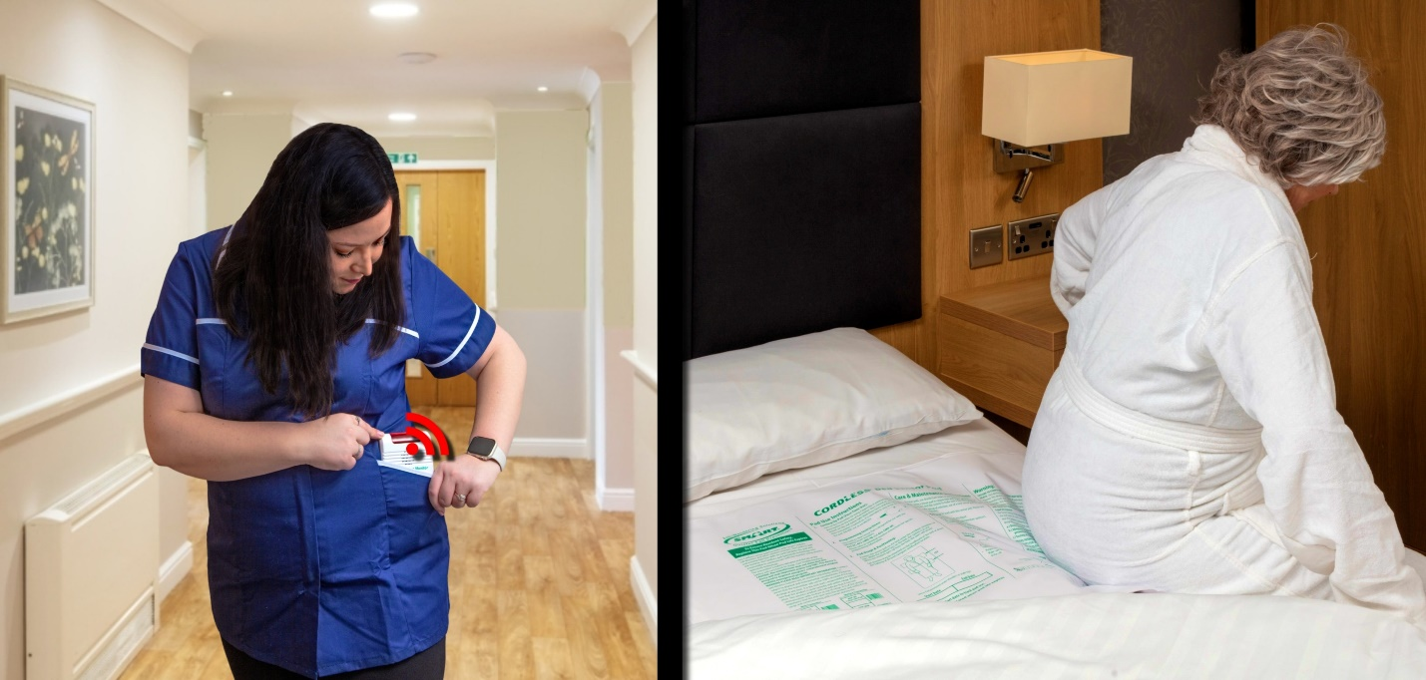

What It Detects Immediately
- Fall events
- Floor lying > threshold
- Bed exits at night
- Prolonged inactivity
- Unusual room movement patterns
No wearables.
No documentation burden.
No workflow change.

Privacy & Risk Protection
- No facial recognition
- No audio recording
- Bathroom-safe zoning
- On-device processing
- Configurable retention policies
Designed for PHIPA-conscious environments.

Operational Impact
Night Shift
- Early detection of bed exits
- Faster response times
- Reduced unwitnessed falls
Clinical
- High-risk room flagging
- Pattern detection over time
- Shift handoff summaries
Executive
- Incident timeline clarity
- Response-time tracking
- Defensible audit trail

Financial Impact
- Reduced fall-related claims
- Lower liability exposure
- Fewer hospital transfers
- Better staffing deployment
One prevented major fall can justify multi-room deployment.

Implementation Timeline
Week 1:
- Install edge appliance
- Mount cameras
- Configure room zones
Week 2:
- Silent monitoring mode
- Threshold calibration
Week 3:
- Full alert activation
No EHR integration required.
No disruption to existing systems.

Expansion Roadmap
After Vision deployment:
ElderOS Guard
- Facility-wide safety intelligence
- Elopement detection
ElderOS CareIQ
- Fall risk prediction
- Deterioration detection
ElderOS Insight
- Executive dashboards
- Staffing vs acuity analytics
Start with safety. Expand into intelligence.

Why This Is Different
Most systems require:
- Integration projects
- Workflow redesign
- Staff retraining
ElderOS starts with:
- Rooms
- Real-time detection
- Immediate value
Safety without complexity.

